Installation of Active Directory Domain Services (AD DS)

Install AD DS Role
- Open Server Manager
- Click Add Roles and Features
- Select Role-based or feature-based installation
- Choose the local server
- Select Active Directory Domain Services
- Click Install

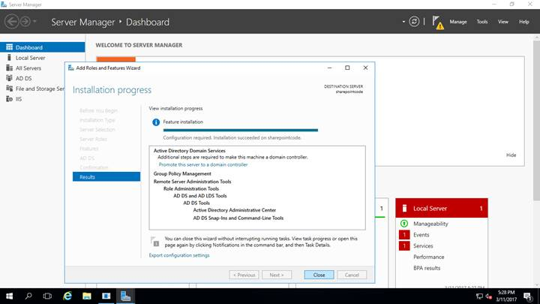

This installs the required services to manage users, computers, and resources centrally.
Screenshot: AD DS installation completed
The installation is finished and now we can create manage users and the security roups now

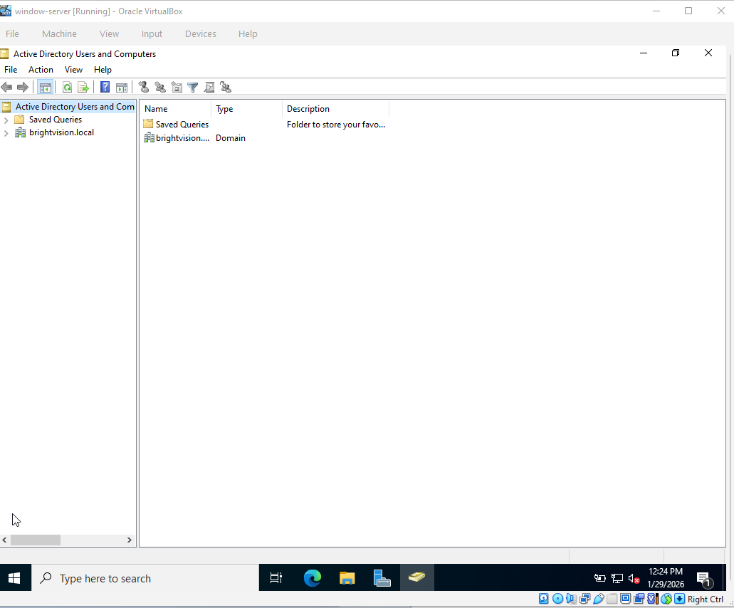

Create Security Groups
Open Active Directory Users and Computers
Create two security groups:
Marketing
Sales
Group scope: Global
Group type: Security
Description:
Security groups are used to manage access to shared resources.
Screenshot: Marketing and Sales groups
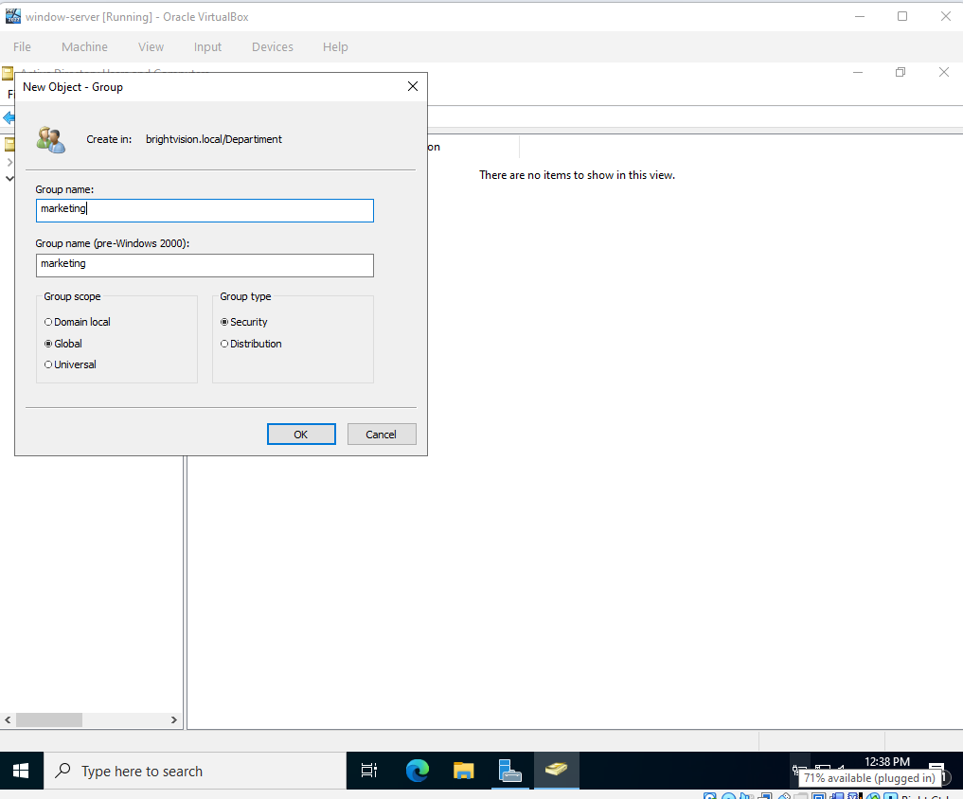

Add Users to Groups
- Add marketing.user to Marketing group
- Add sales.user to Sales group
Description:
This defines which resources each user can access.
Screenshot: Group membership

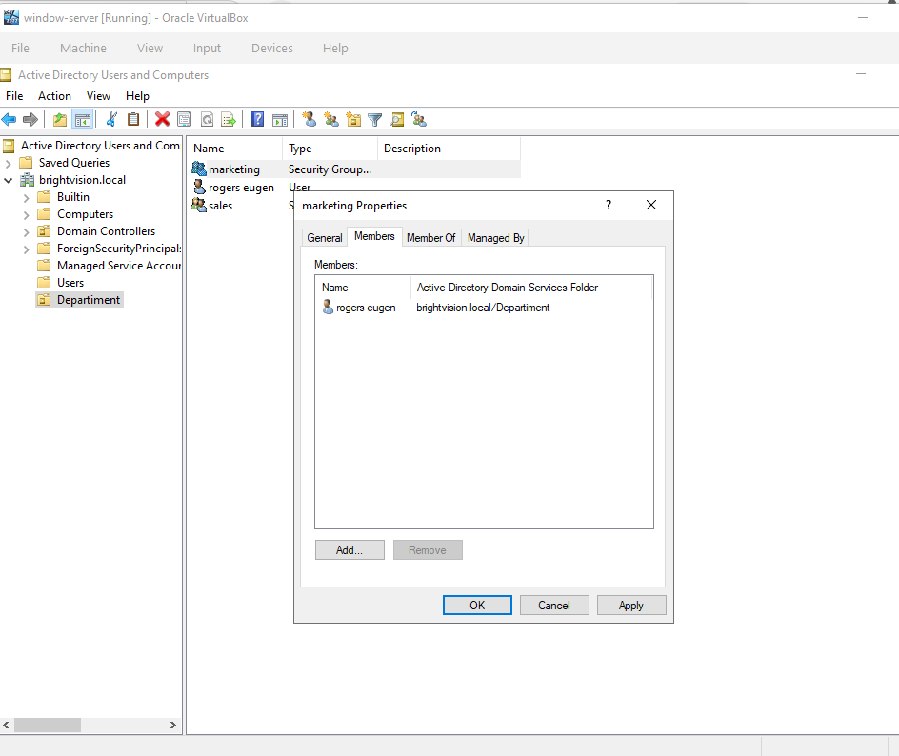

This is the list of all users and the security group of the brightvison.local

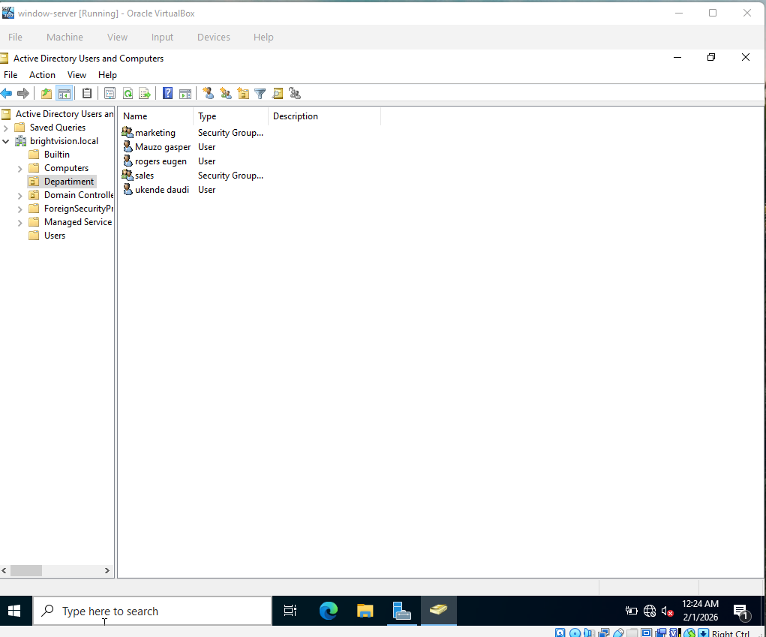

Configure NTFS Permissions

Marketing folder
- Marketing group: Full Control
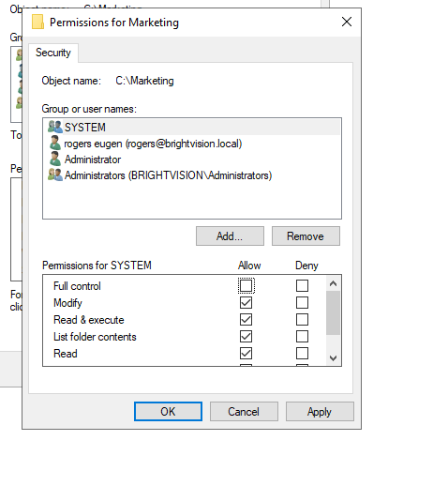

: Configure NTFS Permissions

Sales folder
- Sales group: Full Control

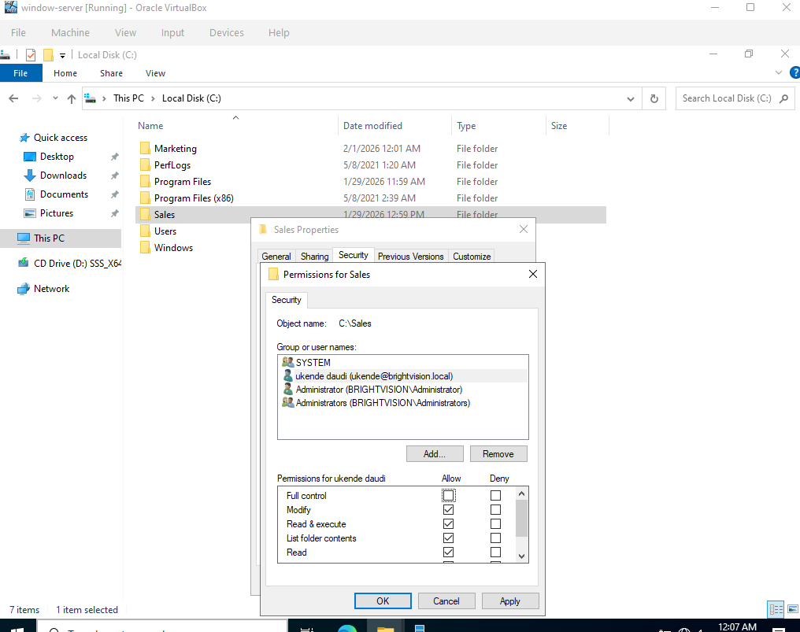

Making the configuration of the DNS server to the client and server the same
-this process ensure thet the dns used on the brightvison.local is the same dns used to the client computer the DNS IP address is 192.168.1.5 we set to both client and the server
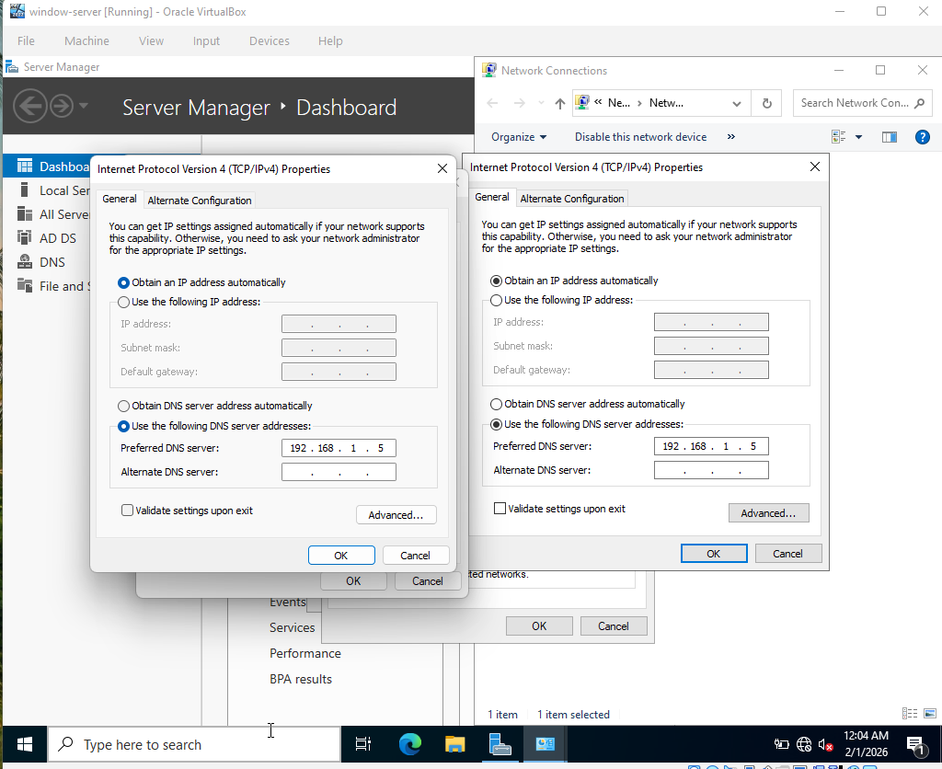

Testing the DNS and ip to the client computer to test the connection using the ip that we are using 192.168.1.5 if its works fine after configuration from the ipv4 on the client computer
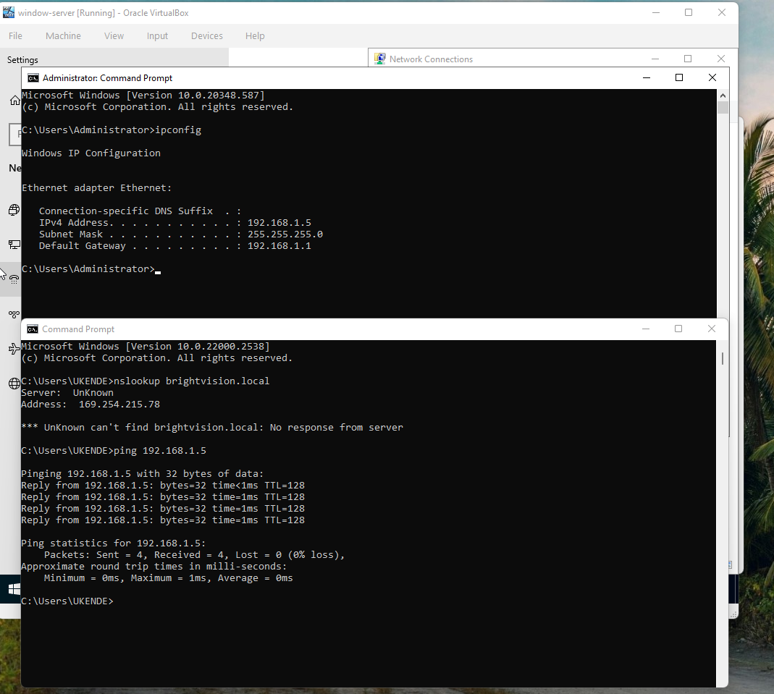

Test the connection to the client computer from the sever
Using the ping brihtvision.local and then it show that the connection is good and the client can get the service from the server brihtvision.local
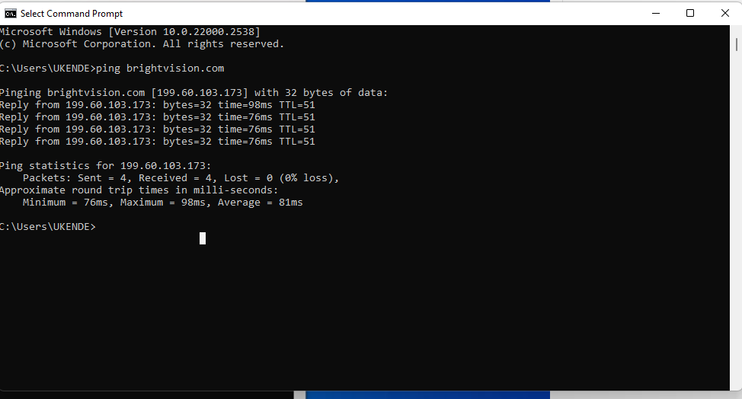

Join Client Computer to Domain
- Open System Properties on client PC
- Click Change settings
- Select Domain
- Enter: brightvision.local
- Provide domain administrator credentials
- Restart the client computer

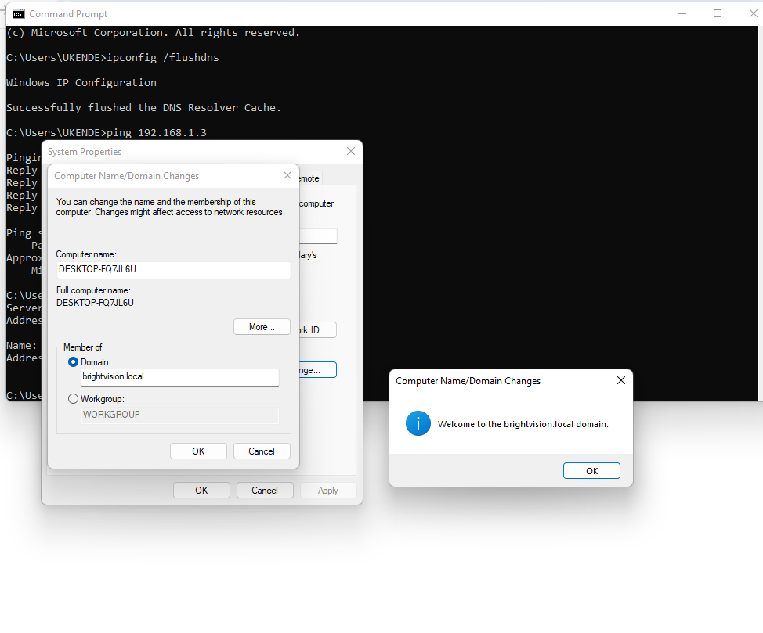

Market user has login to the company with the domain brightvision.local the market user we have created was rogers eugen

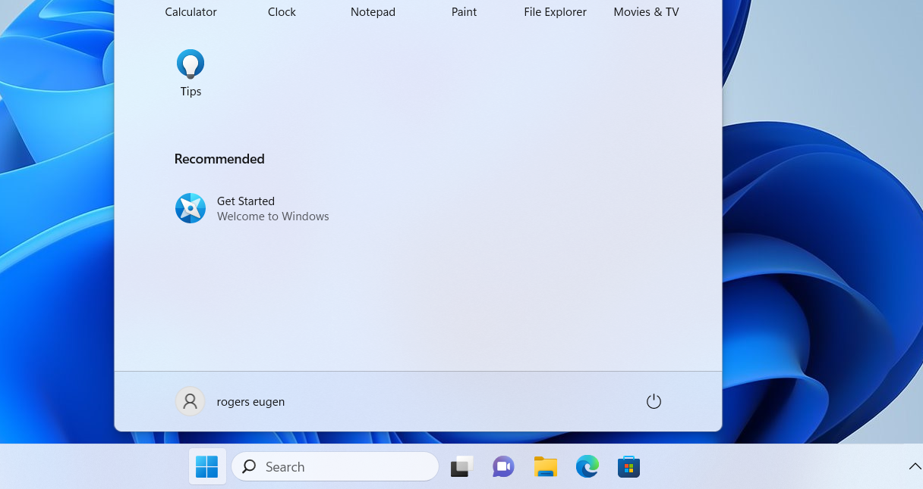

This show that the market user is share the file/document to the marketing folder on the shared folder we had created before the user has role to read and write the folder
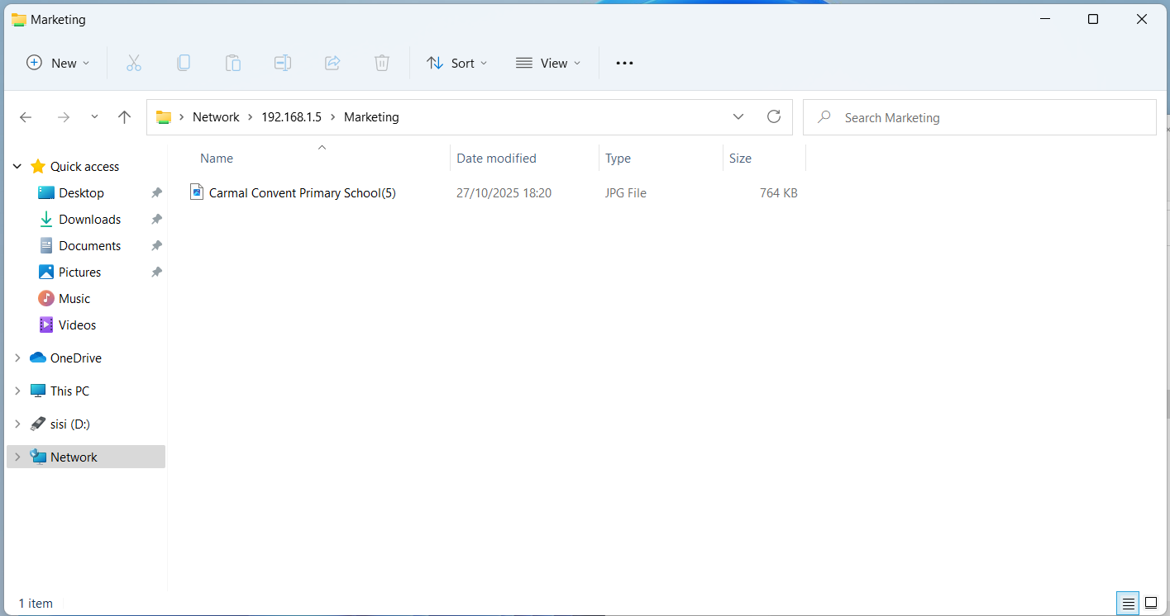

This is the screenshot that show that the sales user isa login to the domain of the company brightvison.local and access the sales folder correct the sales users is called mauzo gasper

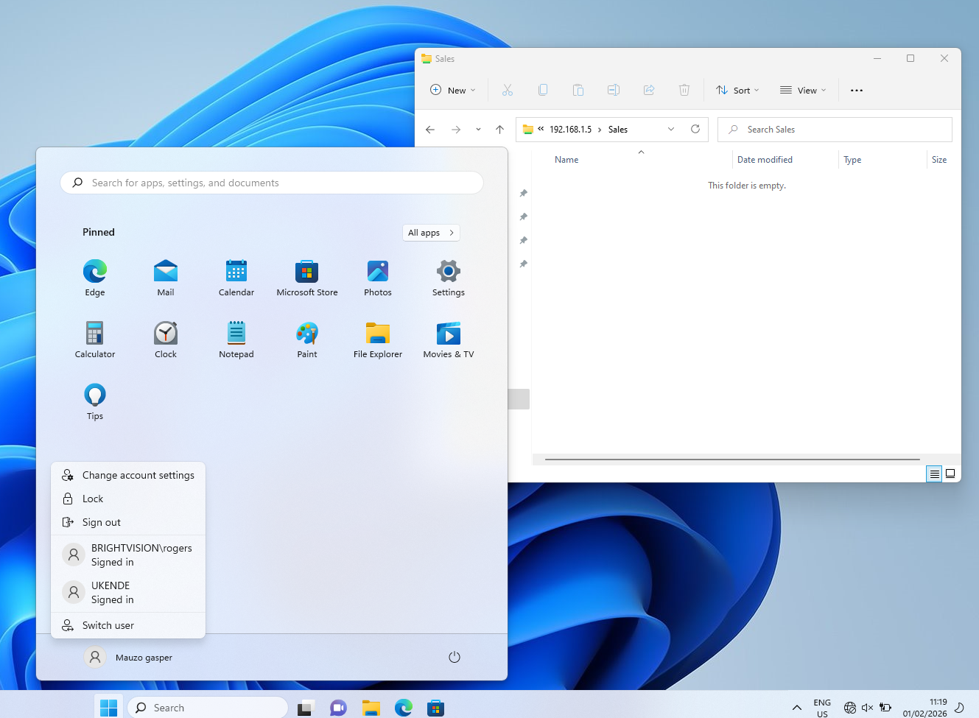

This show that the sales user ia wanted to access the marketing folder and the message pop up and tell him window can not access the \\192.168.1.5\Marketing
